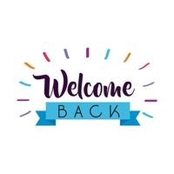
Hi everyone!
My name is Maggie Lewallen and I will be your child’s teacher this year. This is my third year at Morgan! I am so excited for the year we have ahead of us!

A little bit about our class…
In our class we have an educational assistant named Ms. Sue. She has been with me for three years and is amazing! Sue is also from the area and is great with our students. Our classroom routine is highly structured while incorporating various sensory activities and movement breaks throughout the day.

A little bit about me…
I graduated with a dual degree in Early and Special Education in 2019. I am currently enrolled in a Master’s program for Applied Behavior Analysis and work part time as a behavior therapist. I am from Hamilton originally and have just recently moved to Bordentown. I graduated from Steinert High School and attended Yardville and Reynolds.

School Supplies:
If possible please send in snacks for your student as well as a change of clothes. If your child is not toilet trained please send in extra wipes and pull ups.
I am sure you are receiving a lot of emails, but please be on the lookout for additional emails and information from me coming in the next few days!

Please reach out with any questions/concerns. My email is mlewallen@htsdnj.org I am so excited for the year we have ahead of us!
Thanks,
Maggie

